**Creating Developer Account**

* Creating Developer Account
* Creating a developer org in salesforce.
* Go to developers.salesforce.com/Click on sign up.
* On the sign up form, enter the following details :
* First name & Last name
* Email
* Role : Developer
* Company : College Name
* County : India
* Postal Code : pin code
* Username : should be a combination of your name and company This need not be an actual email id, you can give anything in the format : username@organization.com
* Click on sign up after filling these.

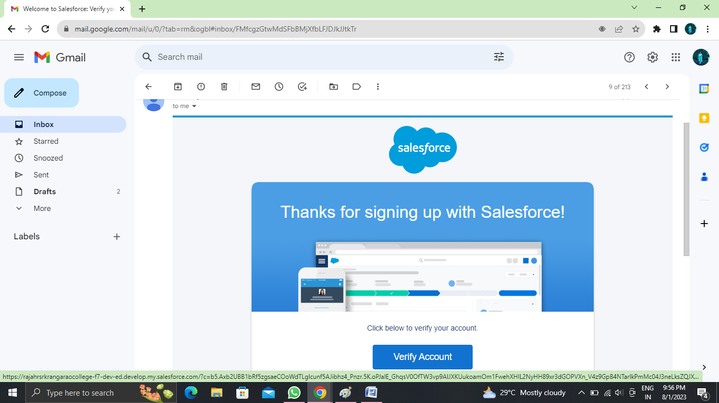

**Custom Objects - Enquiry, Property, Loan**

Custom Objects-Enquiry, Property, Loan,  
 Create Enquiry Object  
  
To Navigate to Setup page  
  
  
  
  
To create an object:  
  
From the setup page ? Click on Object Manager ? Click on Create ? Click on Custom Object.  
  
  
  
On Custom object defining page:  
Enter the label name (lead), plural label name ?(leads), Record name(Customer Name)  
  
  
  
Click on Allow reports, Allow search ? Save

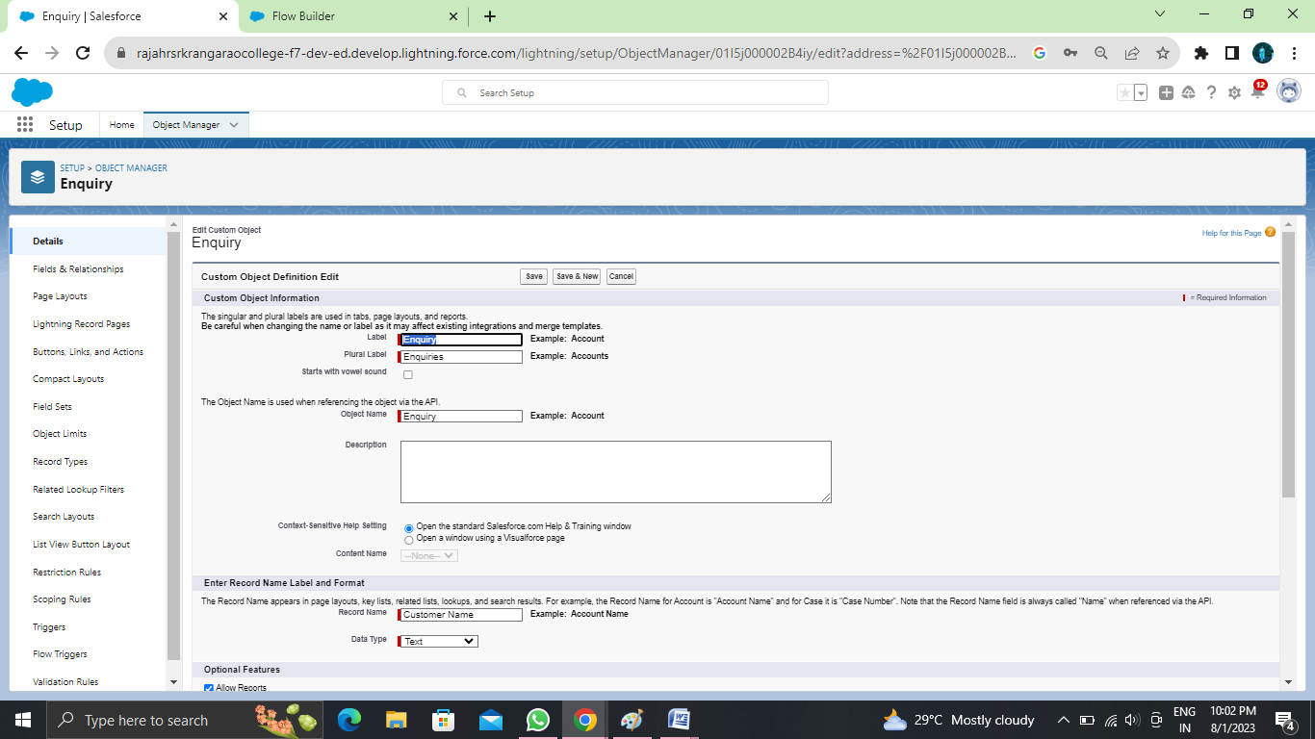

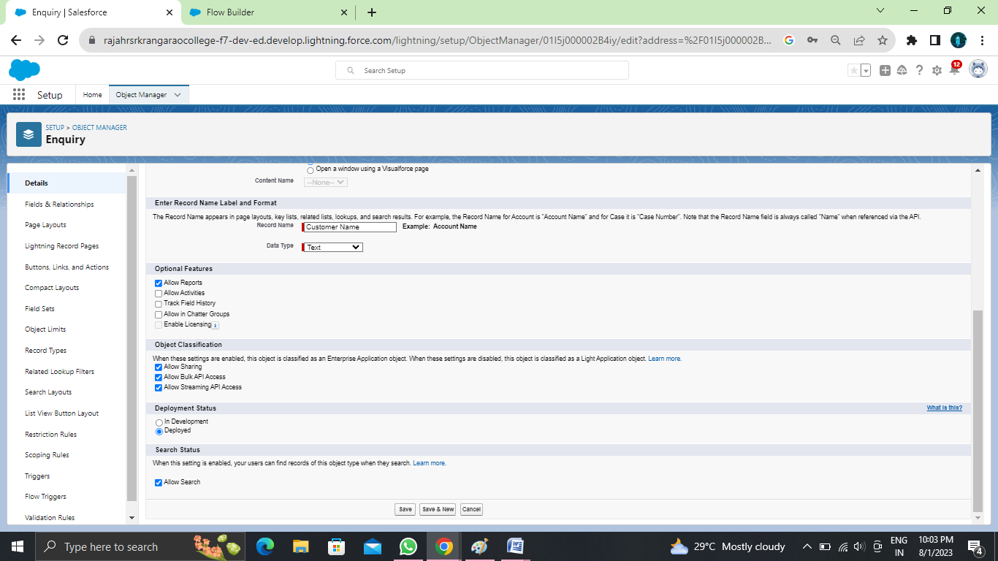

**Create Object Property**

1)To create an object:  
2)From the setup page ? Click on Object Manager ? Click on Create ? Click on Custom Object.  
3)Enter the label name?Property  
4)Plural label name? Properties  
5)Record Name?Property Name  
6)click on Allow reports,  
7)Allow search ? Save

**Create Object Loan**

1.To create an object:  
2.From the setup page ? Click on Object Manager ? Click on Create ? Click on Custom Object.  
3.Enter the label name?Loan  
4.plural label name? Loans  
5.Record Name?Loan Id  
6.Data Type?Auto Number  
7.Display Formate?LN-{0000}  
8.Starting Number?0001  
9.click on Allow reports,  
10.Allow search?Save

### Create The Lightning Tab

Create the Lightning Tab to create a Tab:(enquiries)  
  
Go to setup page ? type Tabs in Quick find bar ? click on tabs ? New (under custom object tab)  
  
  
  
Select Object(Lead) ? Select the tab style ? Next (Add to profiles page) keep it as default ? Next (Add to Custom App) keep it as default ? Save.

**Create A Tab ( Property,Loan )**

**To create a Tab:(Property**)  
1)Go to setup page ? type Tabs in Quick Find bar ? click on tabs ? New (under custom object tab)  
2)Select Object(Property) ? Select the tab style ? Next (Add to profiles page) keep it asdefault ? Next (Add to Custom App) keep it as default ? Save.Activity4:  
  
**To create a Tab:(Loan)**  
1)Go to setup page ? type Tabs in Quick Find bar ? click on tabs ? New (under custom object tab)  
2)Select Object(Buy) ? Select the tab style ? Next (Add to profiles page) keep it as default ? Next (Add to Custom App) keep it as default ? Save

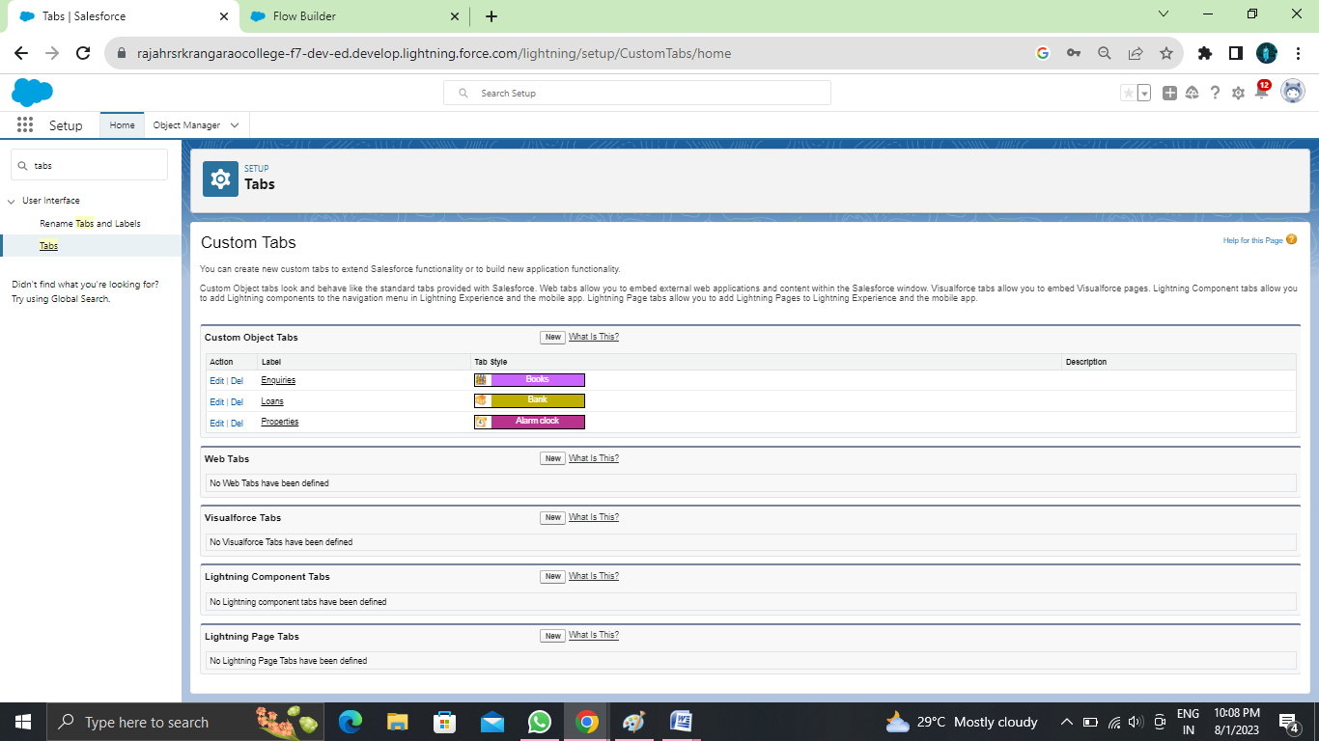

Go to setup page ? search “app manager” in quick find ? select “app manager” ? click on New lightning App.  
  
  
  
Fill the app name as an Property Management in app details and branding ?Next ? (App option page) keep it as default ? Next  
  
  
  
(Utility Items) keep it as default ? Next ? (Add User Profile) Add System Administrator, Salesforce platform user, Standard User ? Next.  
  
To Add Navigation Items:  
( Lead, Property, Loan, Report, Dashboard) Select the items from the search bar and move it using the arrow button ? Next.  
  
  
  
To Add User Profiles:  
( System Administrator, Salesforce platform user, Standard User)  
Search profiles in search bar ? click on the arrow button ? save & finish.

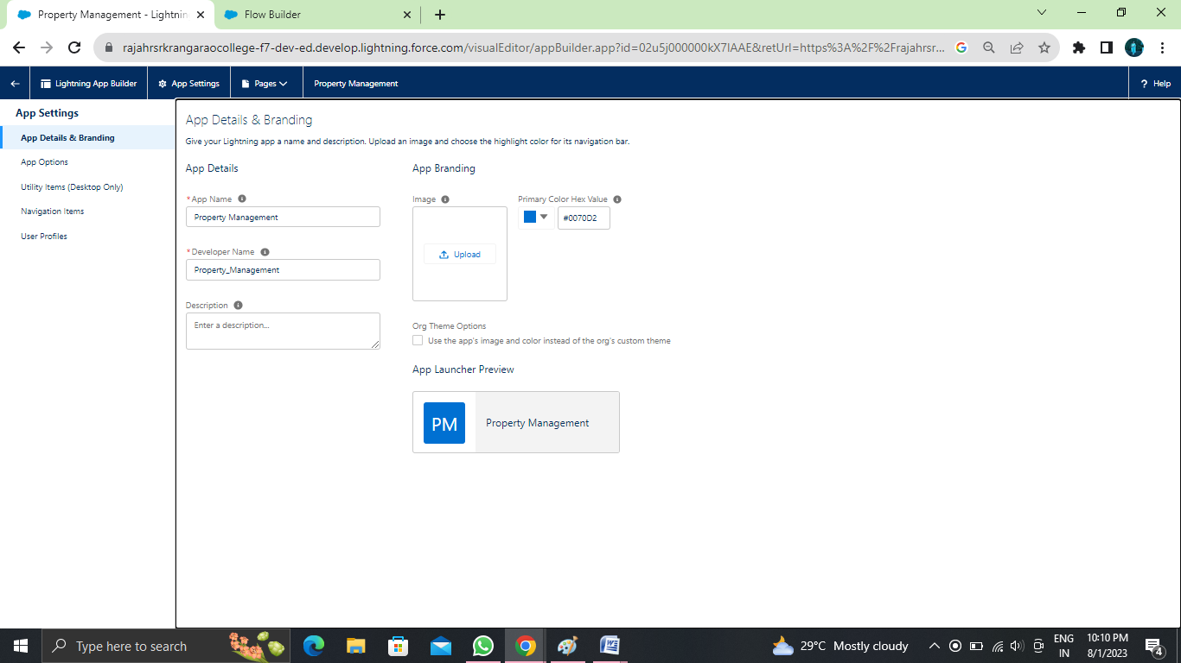

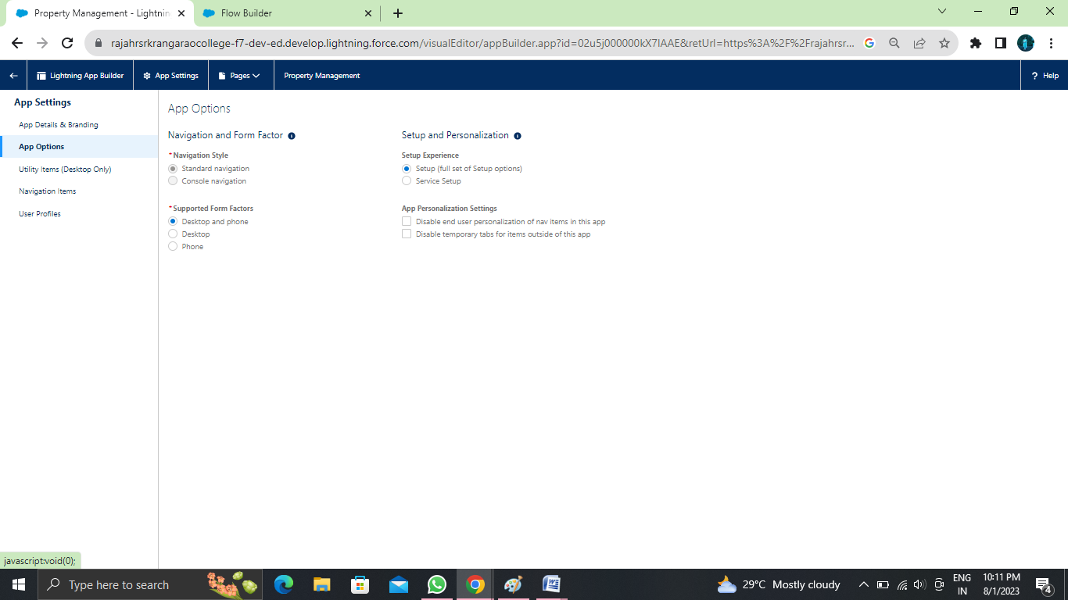

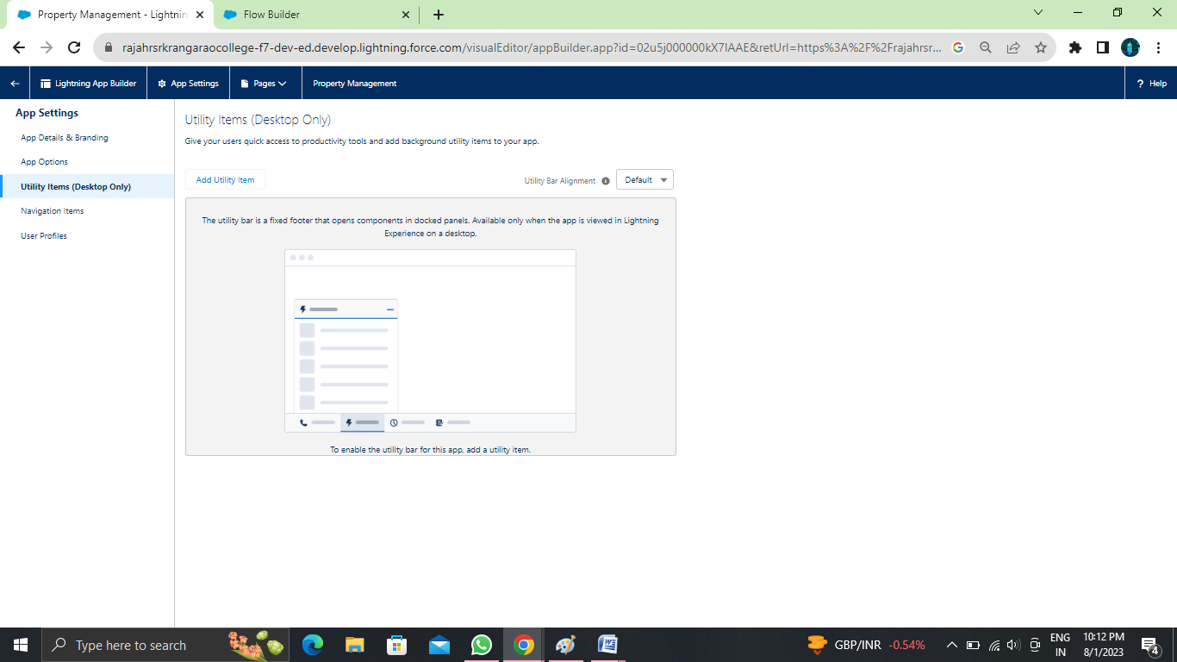

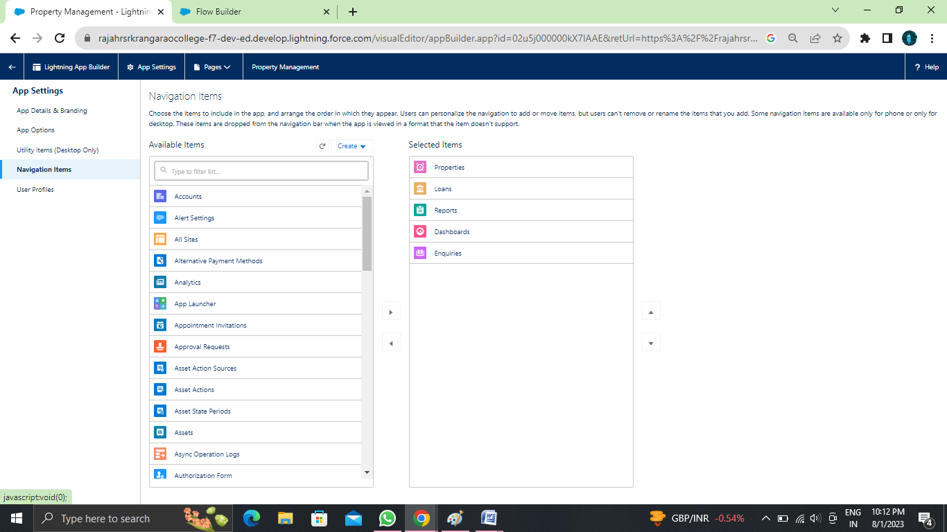

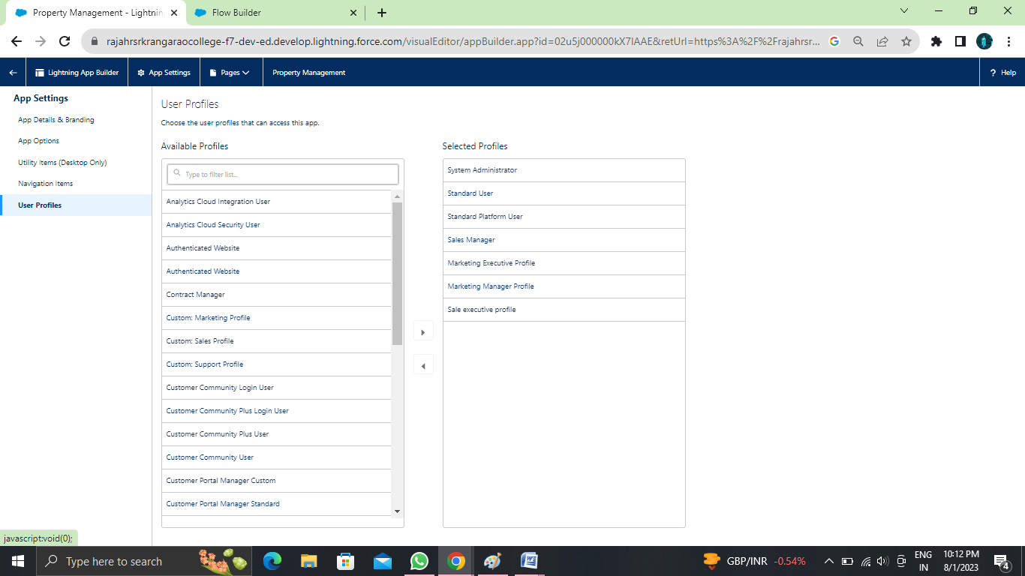

**Create Fields**

1. Go to setup ? click on Object Manager ? type object name in search bar ? click on the object  
  
  
  
  
2.Now click on “Fields & Relationships” ? New.  
  
   
  
Select Datatype (Auto number)  
  
  
  
3. Fill the field label name Lead Number, Datatype (autonumber) ? Next ? Next ? Save.  
  
  
  
  
Create the remaining Fields:  
  
Follow the above activity 1 Steps 1 to 2, create the Field just change the Labels and data types for Below Fields  
  
Lead Type: Create the picklist fields by the values (Buy, Rent) State: Create the Picklist Fields (Maharashtra, Gujarat, Rajasthan) City: Create the Picklist Fields (Nashik, Surat, Jaipur)  
Email: Create the Email Select the Data Type as Email (Email)  
Phone: Select the Field Data type as (Phone)

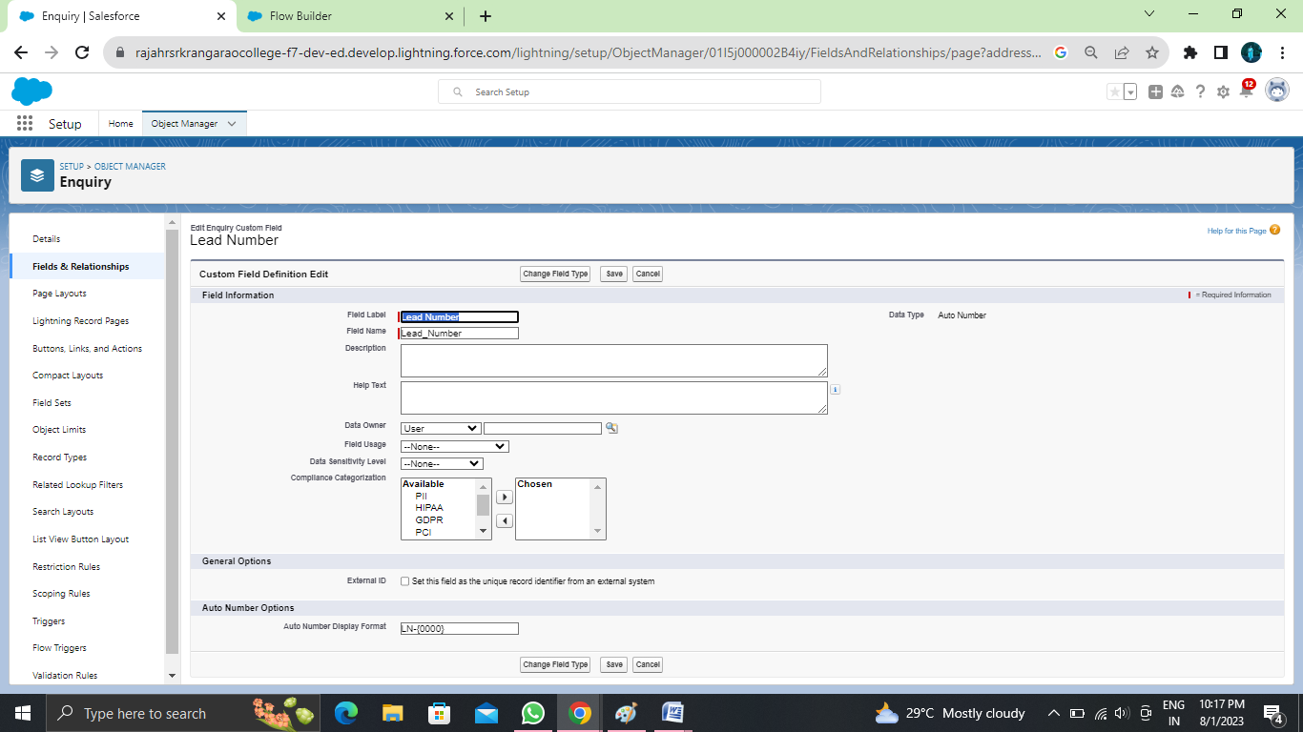

**Create Picklist Field On Enquiry Object**

Create picklist fields on enquiry object

1. Click on the gear icon and then select Setup.
2. Click on the object manager tab just beside the home tab.
3. After the above steps, Select enquiry Object

Now Select Fields and relationships from setup menu of the enquiry object.

1. Click new and select Picklist fields ????next and enter label name(State) and select enter values option((Maharashtra, Gujarat, Rajasthan),next and Save
2. Note: we create picklist fields for city follow the above steps just change the Labels and values.

Create Field Dependency(on enquiry objects)

1. Create a dependency between these two picklists, so that when a state is selected, only respective Values are available.
2. The below steps will assist you in creating Field Dependencies.
3. Click on the gear icon and then select Setup.
4. Click on the object manager tab just beside the home tab.
5. After the above steps, Select enquiry Object
6. Now Select Fields and relationships from setup menu of the enquiry object.
7. Click Field Dependencies.
8. Click New.
9. Select State as the Controlling Field and select City as the Dependent Field.
10. Click Continue.
11. Select the appropriate Value in each column by double-clicking them.
12. Maharashtra:i) Nashik
13. Click Include Values. And it is also same for Gujarat & Rajasthan with its city.
14. Click Preview, then test the dependency by selecting different State and viewing the associate Values available for Particular state.
15. Click Close to close the preview window.
16. Click Save.

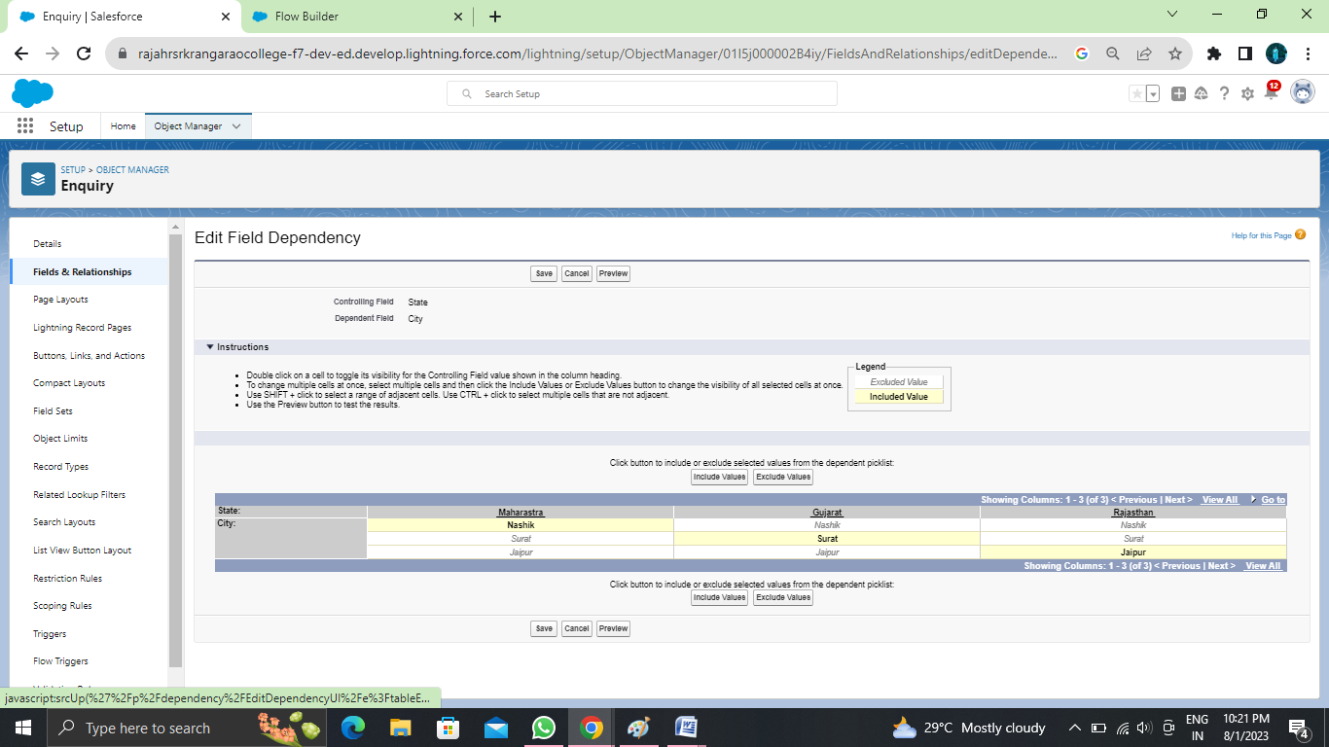

**For Property Object**

Create the remaining Fields:  
  
Follow the above activity 1 Steps 1 to 2, create the Field just change the Labels and data types for Below Fields.  
  
1.Customer name (lookup relationship related to Enquiry)  
2.Create Property Type: (Picklist fields) (Residential, Commercial, Industrial) (Field Dependency)  
3.Residential: Picklist fields (1BHK, 2BHK, 3BHK) (Field Dependency)  
4.Commercial: Picklist fields (Shop, Office) (Field Dependency)  
5.Industrial: Picklist fields (Factory, Mall) (Field Dependency)  
  
Note: In above picklist fields Property type is control field and Residential, Commercial, Industrial is dependent field  
  
  
6.State: Create the Picklist Field (Maharashtra, Gujarat, Rajasthan)(Field Dependency)  
7.City:(Take Any City for Field Dependency)  
  
Note: In above picklist fields State is a control fields and city is dependent field  
  
8.Discount:(Percentage As the Field Data Type)  
9.Price: (Number As the Field Data Type)  
10.Loan Amount: (Currency As the Field Data Type)  
  
For the Property Object? Go to the fields and Relationship and select the formula in field data type. In Formula option select Advanced Formula and write the followingformula.  
Lead_Id r.Customer_Name   c

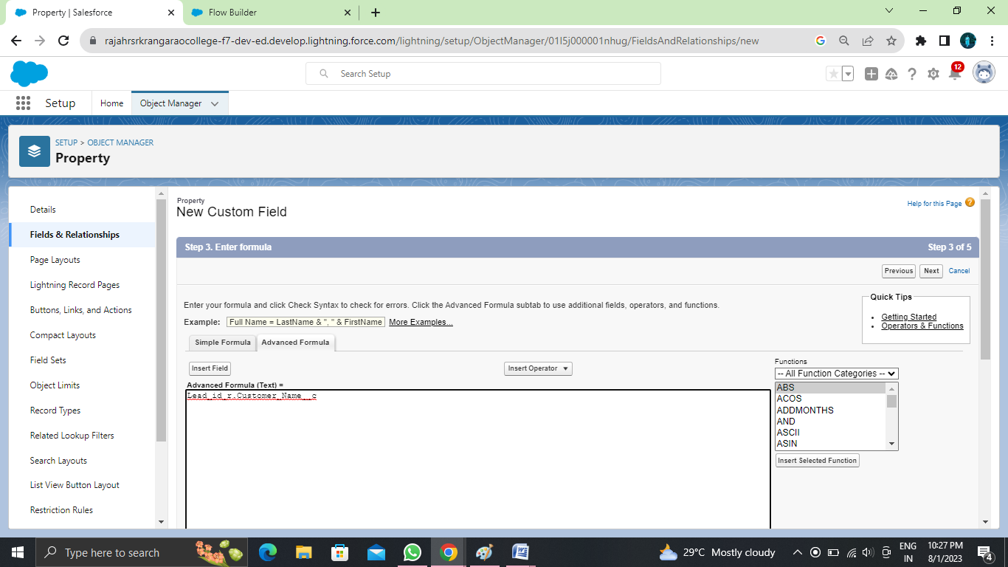

**For Loan Object**

Create the remaining Fields:  
Follow the above activity 1 Steps 1 to 2, create the Field just change the Labels and data types for   
Below Fields  
1. Property name: (lookup relationship related to property)  
2. Customer name: (lookup relationship related to Enquiry)  
3. Interest Rate: (Select the Field Data Type As Currency)  
4. Term: (Select the Field Data type as Number)  
5. Annual Loan: Field create the Number as the field data type  
6. Total Loan Installments: ( Field create the Number as the field data type)  
7. Loan Repayment: ( Field create the Number as the field data type)  
8. Loan Amount: (Select the Field data type as Formula)  
For the Loan Object? Go to the fields and Relationship and select the formula in  
field data type. In Formula option select Advanced Formula and write the following  
formula  
(Loan_Repayment__c* (((1+( Interest_Rate__c/52))^ Term__c) -1))/((   
Interest_Rate__c/52)*((1+( Interest_Rate__c/52))^ Term__c))  
##Check the syntax below whether the formula syntax is correct or not  
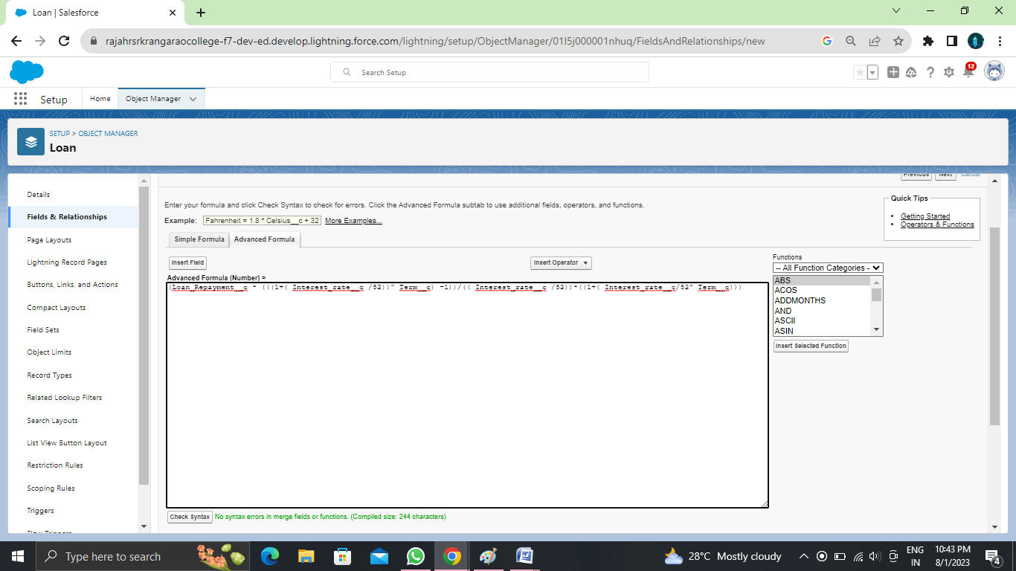

**Create Page Layout For Property Object**

Create a page layout for Property Object  
  
  
Go to setup ? click on Object Manager ? type object name in search bar ? click on the object  
Now click on “Page Layout” ? New.

We can add or remove the the page layout field with the help of drag and drop

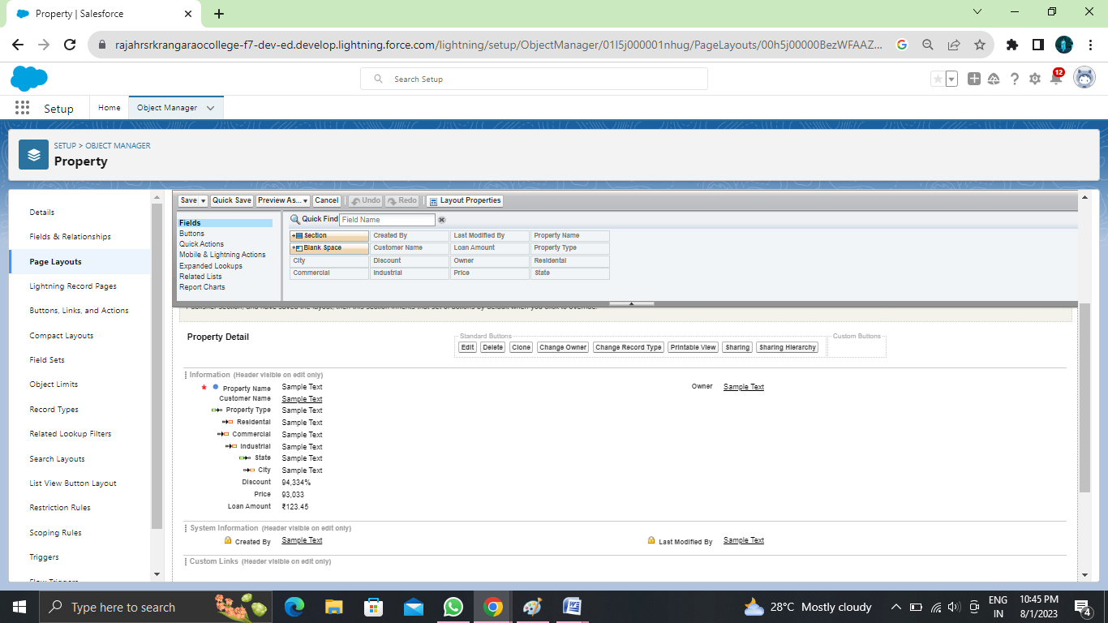

**Rent Page Layout**

Create another page layout name as (Rent) with the help of above steps of activity 1. And remove the discount and loan amount fields from the rent page layout

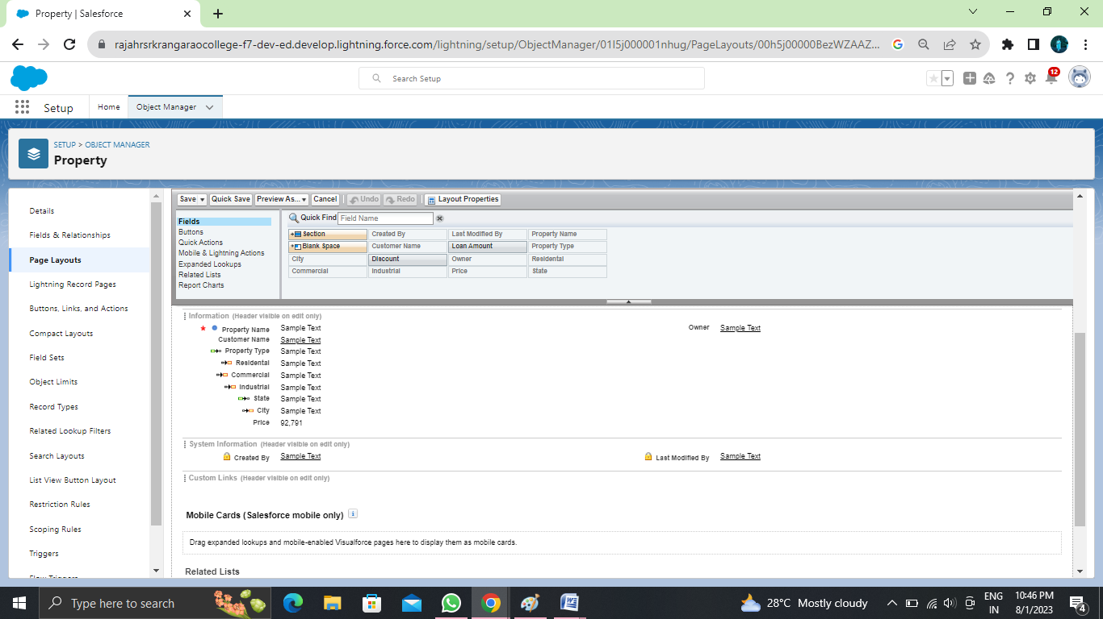

**Record Type For Property Object**

Go to setup ? click on Object Manager ? type object name in search bar ? click on the object  
Now click on “Record type ” ? New.

Enter the record type label as (Buy) and selective active checkbox next and save

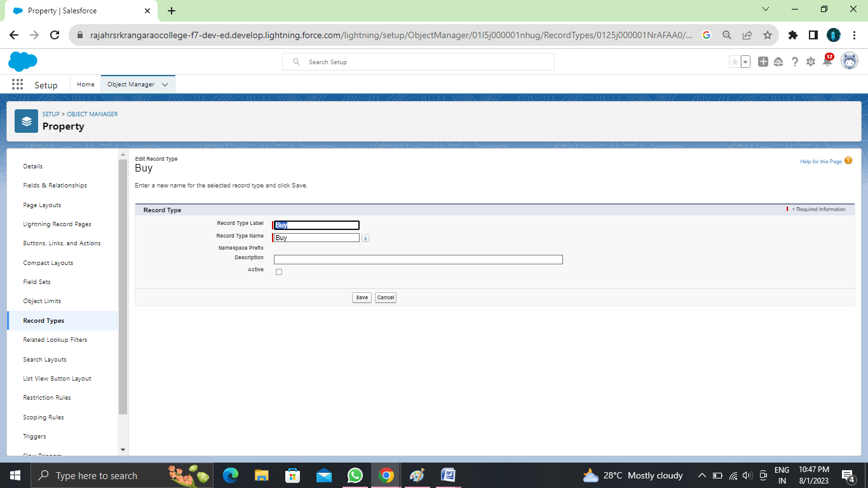

**Record Type Rent**

Create report type name has Rent with the above steps of activity-3

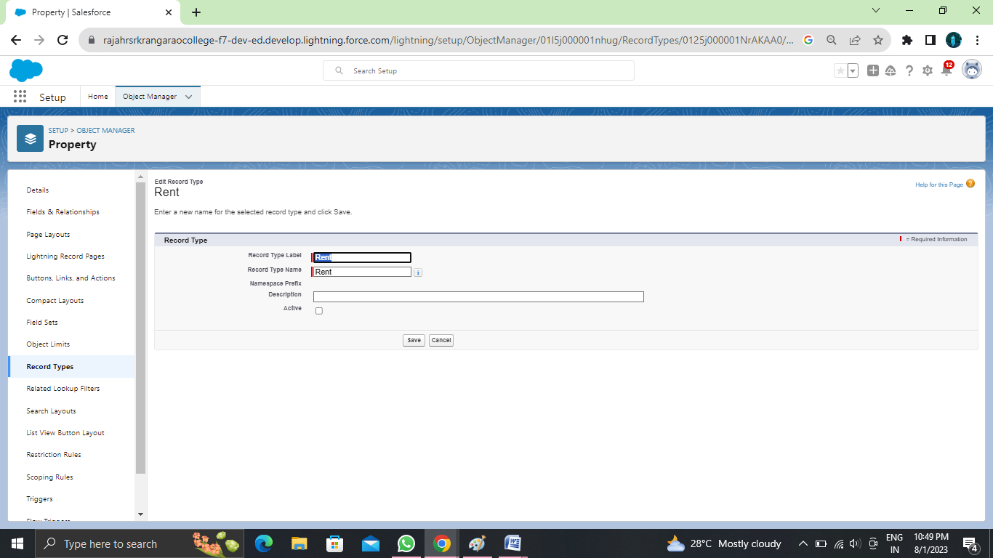

**Page Layout Assignment**

1. Go to setup ? click on Object Manager ? type object name in search bar ? click on the object
2. Now click on “page layout ” ? click page layout assignment
3. Select the buy record type and select page layout to use(buy) then click on save.

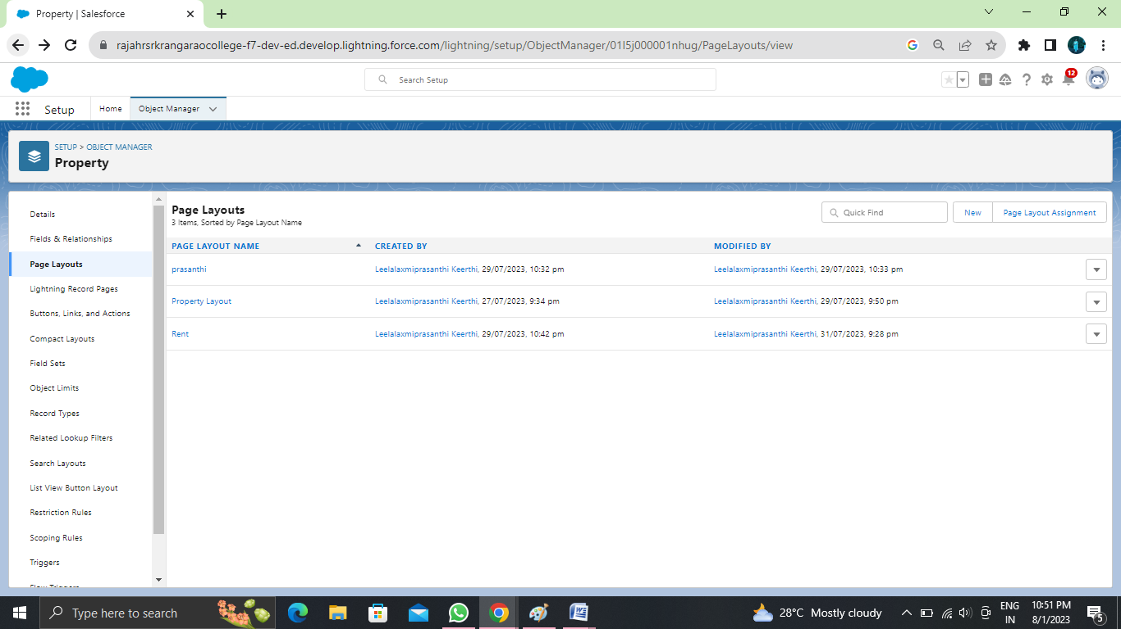

**Page Layout Assignment For Rent**

Follow above 1 to 3 steps  
We assign rent page layout for rent record type.

**Create A New Profile**

To create a new profile:

Go to setup ? type profiles in quick find box ? click on profiles ? clone the desired profile (standard user is preferable).

Enter a Profile Name(Sales Manager) And click on Save  
  
  
  
  
  
  
Click on the new created profile  
  
  
  
While still on the profile page, then click Edit.  
  
  
Scroll down to Custom Object Permissions and Give view all access permissions for Lead, Property, Loan and save(Sales Manager also Having Create, Edit, Delete for Lead, property, loan objects)

6.Create Remaining Profiles

Follow the Above Steps to create the Profile just change the Name for below profiles Clone profile (Standard Platform User) for below all profiles

(a). Marketing Executive profile (b). Marketing Manager profile

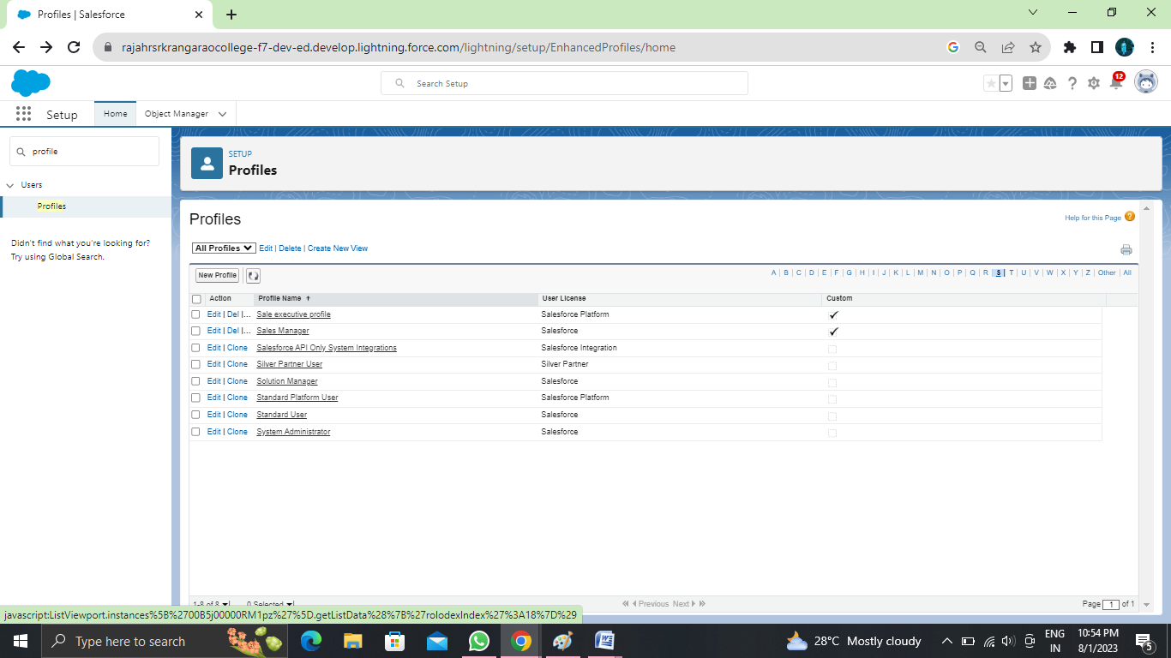

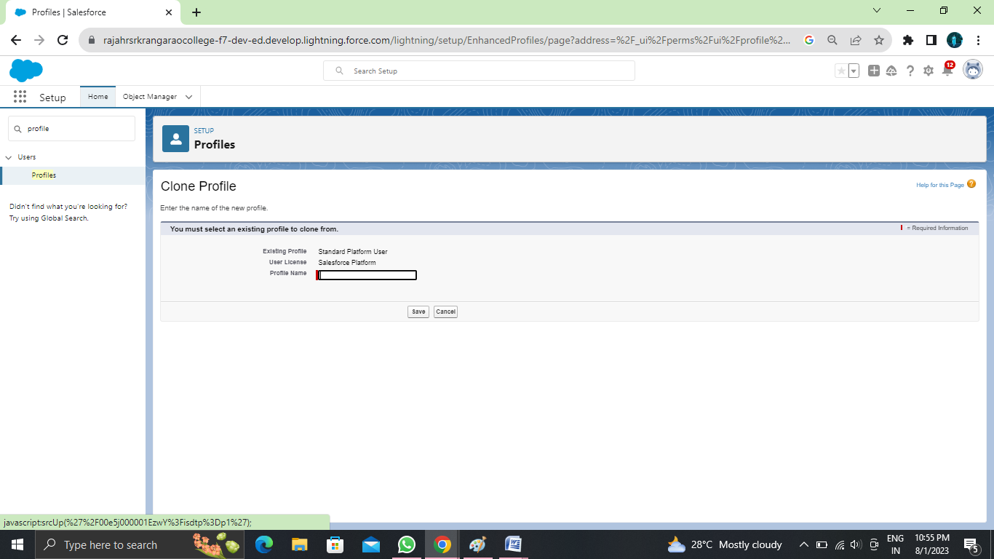

**Create Marketing Executive Profile**

Create Marketing Executive Profile

1.Then In The Profile Level Give Read and Create Access for Lead, property, loan objects to Marketing Executive profile and Read, Create, Edit, Delete for the Marketing manager profile for Lead, property, loan objects  
2.Marketing Manager profile Should Have Access to Marketing Executive profile

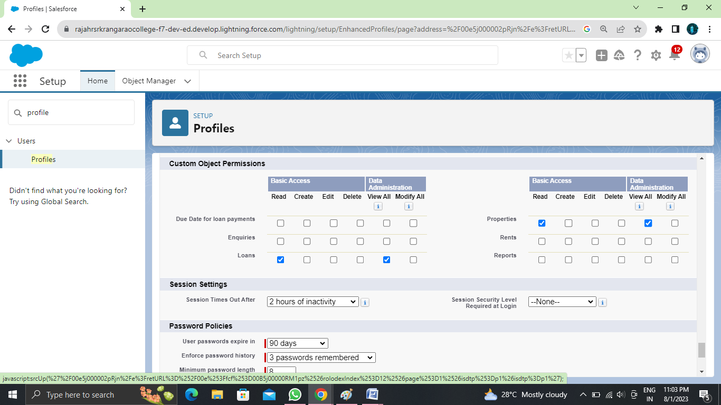

**Create Sales Executive Profile**

Activity3- Create Sales Executive Profile:  
 Follow the Above Steps to create the Profile just change the Name for Below profiles clone profile (StandardPlatform User) ,profile name (Sales executive profile).  
And assign a sales rep1 permission set  
For Sales Rep1? Read, Create, Edit for lead, property and loan objects. For Sales Rep3? Read only.  
  
Note: above 2 are permission set and assign a permission set according to user need. We will discuss in next milestone.

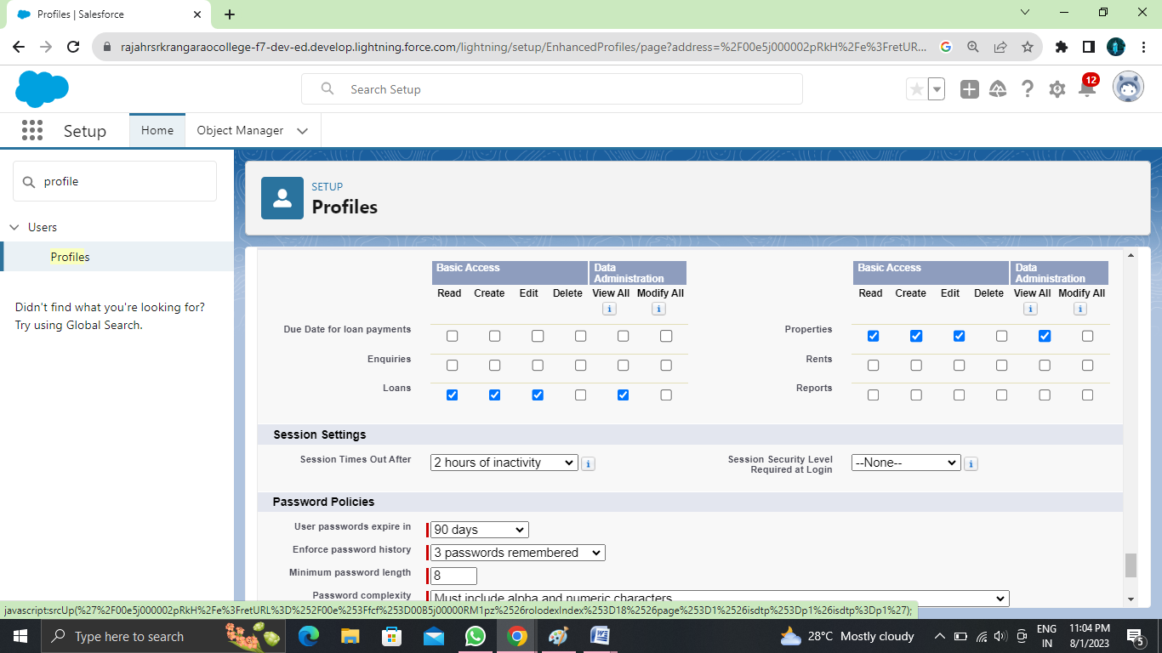

**Create User**

1. Go to setup ? type users in quick find box ? select users ? click New user.  
  
  
First Name: Sunny  
Last Name: Gupta  
Alias: Sanj  
Email: provide your personal email id for future reference  
Username: sunnygupta@thesmartbridge.com  
  
Nickname: Sunny  
Role: leave it as default  
User License: Salesforce  
Profile: Sales Manager and Click Save Button.  
  
Note: Assign Profile according to user requirement.

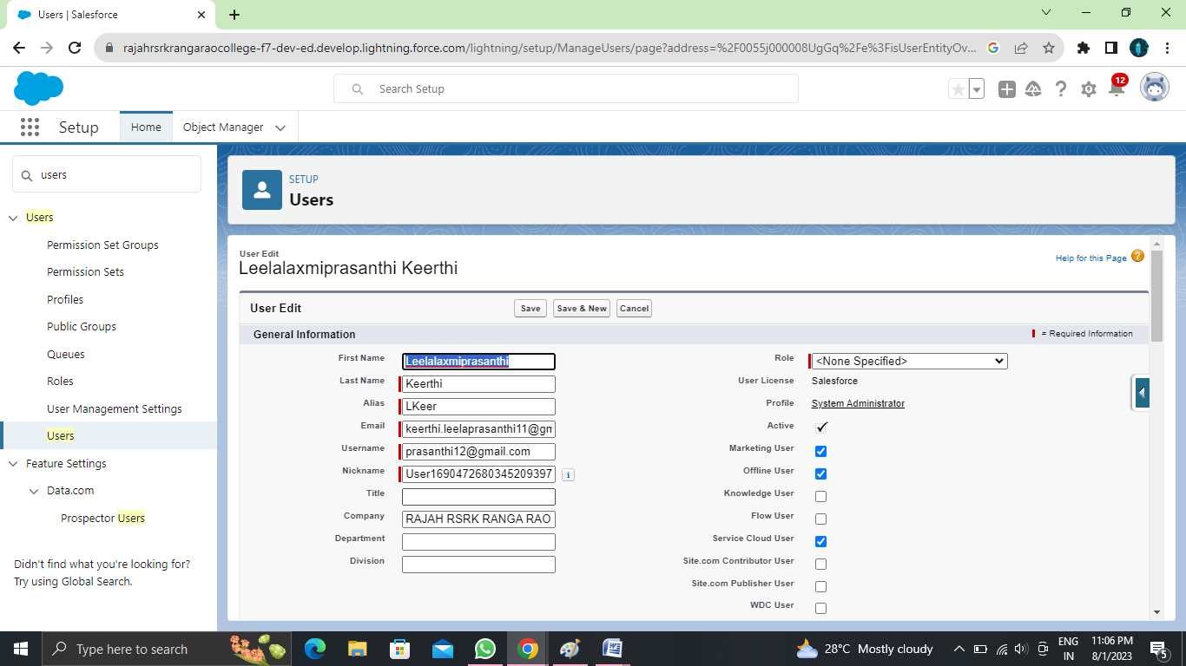

**Create Permission Set**

1. Go to setup ? type “permission sets” in quick search ? select permission sets ? New
2. Enter the label name (Sales Rep Advance) ? save
3. Select Object settings
4. Search object property and select property object. and click Edit button
5. In Object Permission we give View all permission. And click save button
6. Repeat 4th and 5th steps for Enquiry and Loan objects.
7. After saving the permission click on the Manage assignment
8. Now click on the Add Assignment
9. Now select the user (sunny) and click on next & assign.

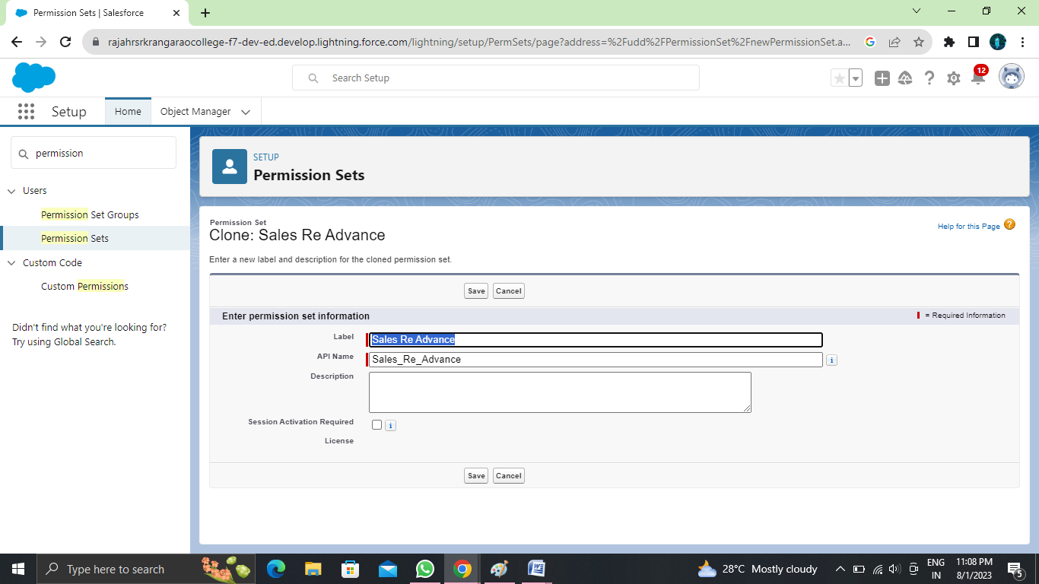

**Create OWD Setting**

1.Setup, use the Quick Find box to find Sharing Settings.  
2.Click Edit in the Organization-Wide Defaults area.  
3.For each object, select the default access you want to give everyone.  
4.To disable automatic access using your hierarchies, deselect Grant Access Using Hierarchies for Enquiry, Property custom object  
  
5.Click Edit and from the Drop Down select private for internal and external  
6.This Setting is for all the User Which have been Created

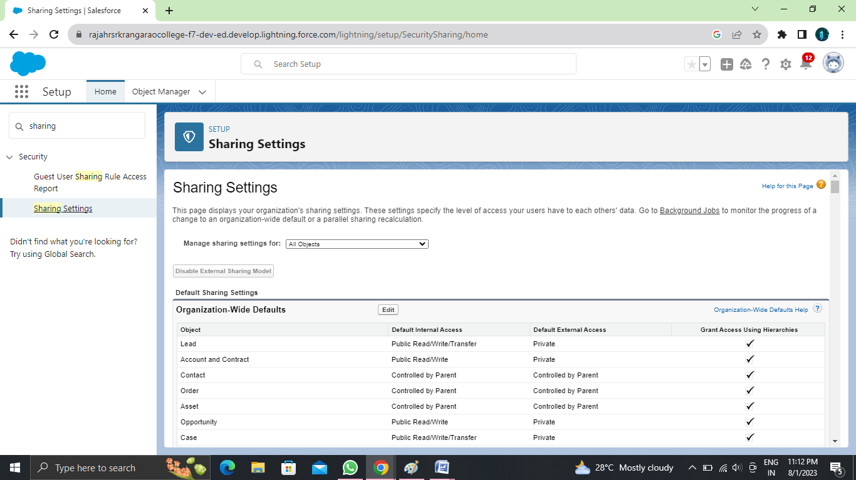

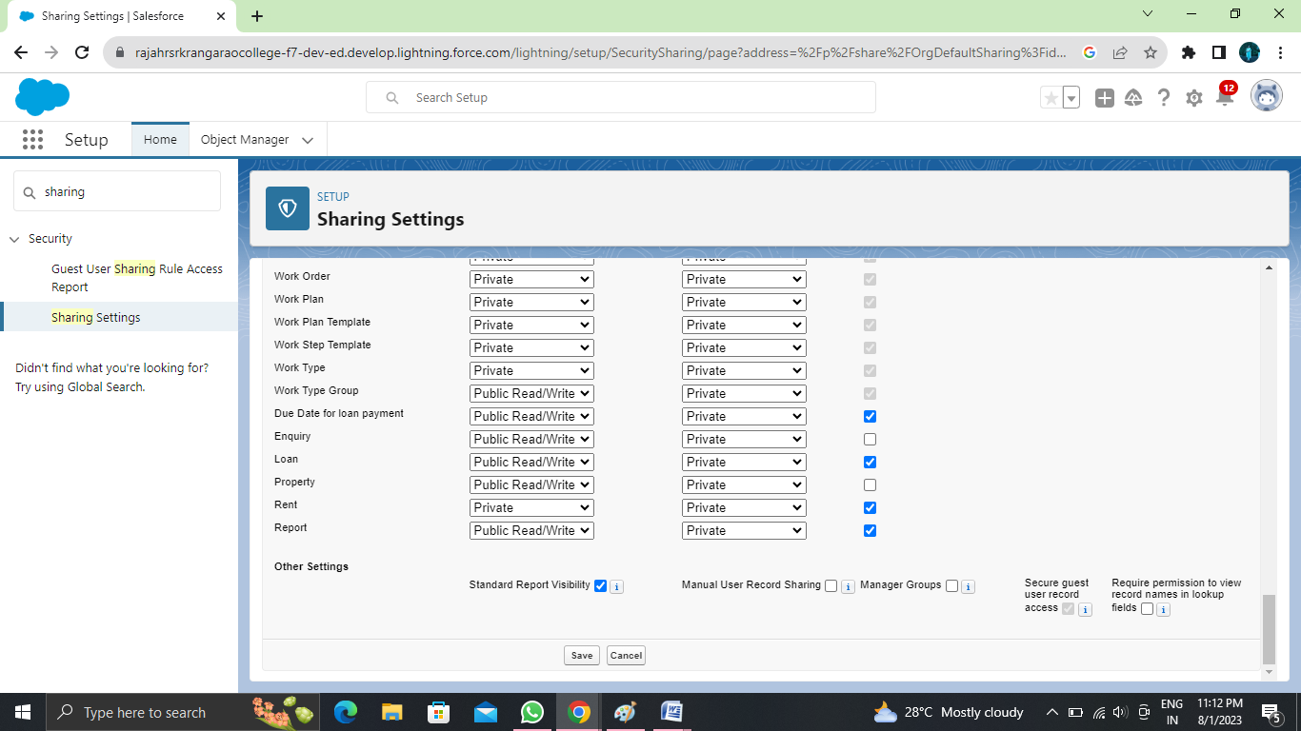

**Create A Record(Enquiry)**

1. Click on App Launcher on left side of screen.
2. Search Property Management & click on it.
3. Click on Inquiries Tab.
4. Click new and fill details & Save

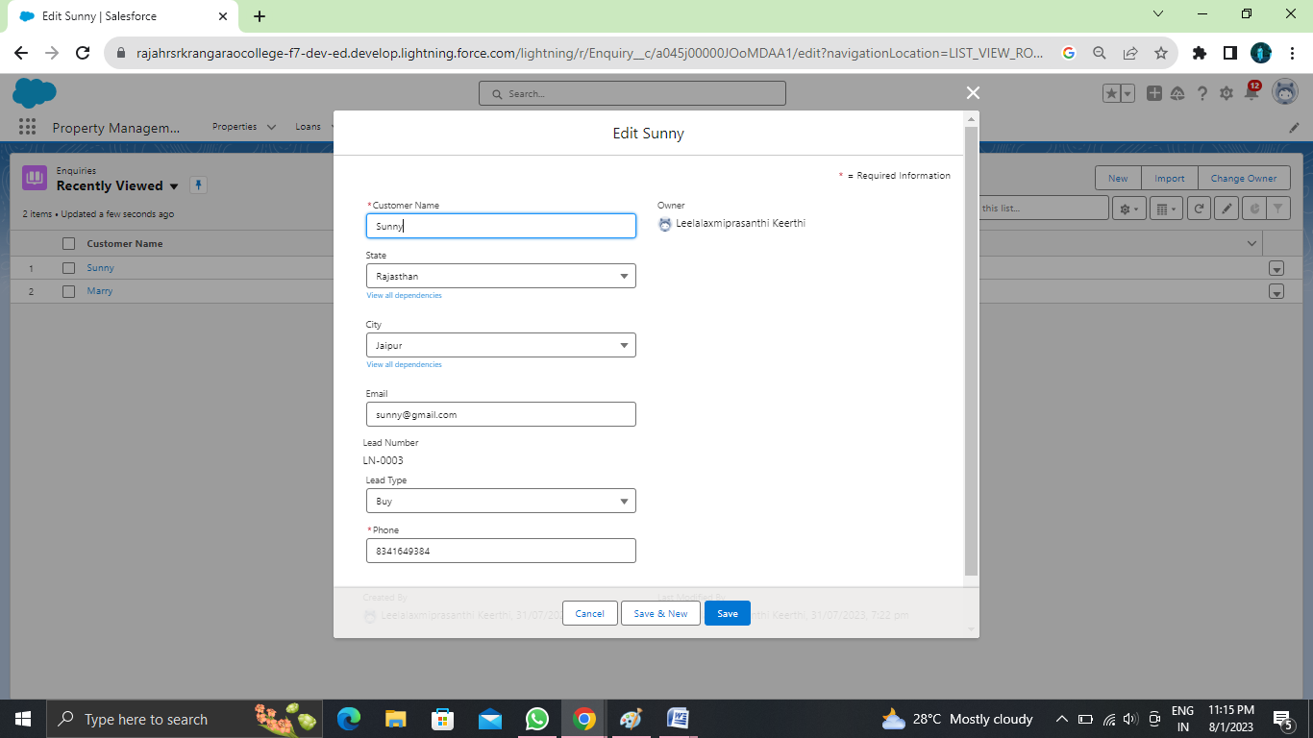

**View A Record(Enquiry)**

1. Click on App Launcher on left side of screen.
2. Search Property Management & click on it.
3. Click on Inquiries Tab.
4. Click on any record name. you can see the details of the Event

**Delete A Record(Enquiry)**

1. Click on App Launcher on left side of screen.
2. Search Property Management & click on it.
3. Click on Inquiries Tab.
4. Click on Arrow at right hand side on that Particular record.
5. Click delete and delete again.

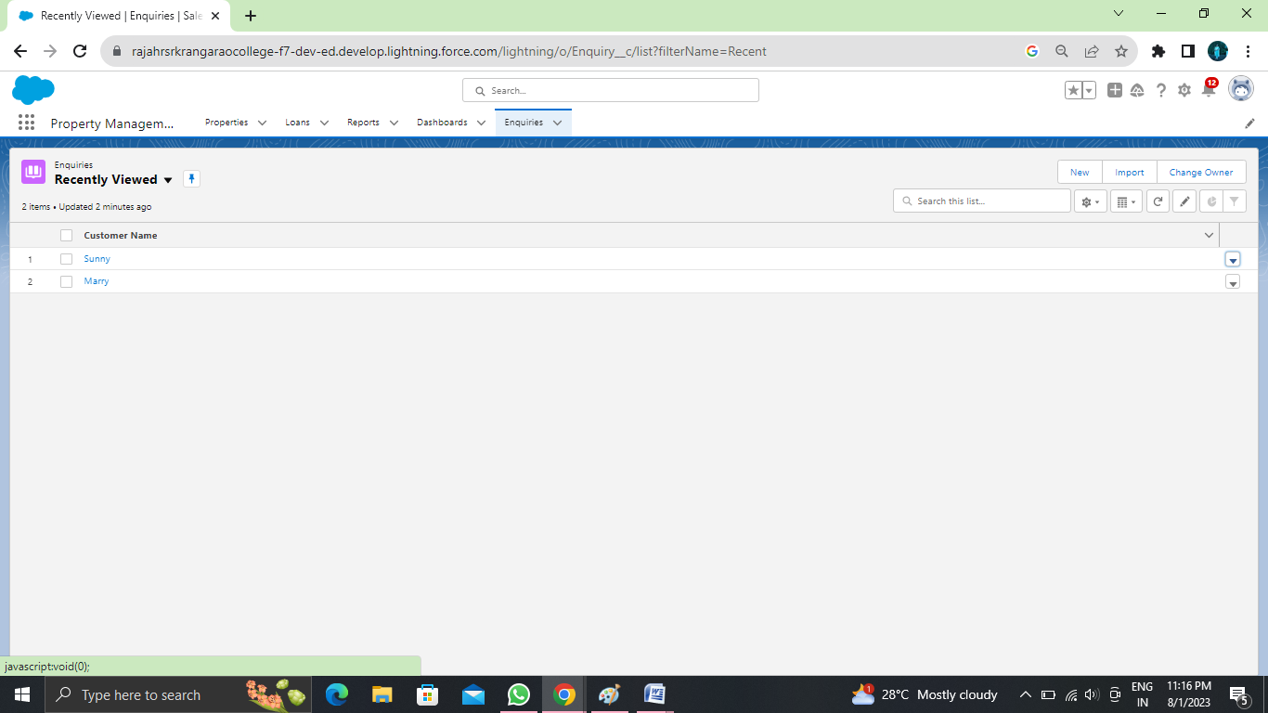

**Create Report**

1. Go to the app ? click on the reports ta

